**EE462 UTULIZATION OF ELECTRIC ENERGY PROJECT 0**

Deniz Şahin

1938026

**Short Info about Motor**

There are many type of motor exist but for simplicity let’s consider the permanent magnet DC motor shown as figure 1. $V_{t}$ Is the terminal voltage and $E_{a}$ is the motor voltage. This motor voltage is depend on the speed of the motor ($w_{m}$) and voltage constant of the motor ${(k}_{E})$. We can say that motor voltage is directly proportional to speed of the motor. Also armature current is calculated by the terminal voltage, motor voltage and armature resistance. In addition, when speed increase armature current decrease so produced torque decrease.

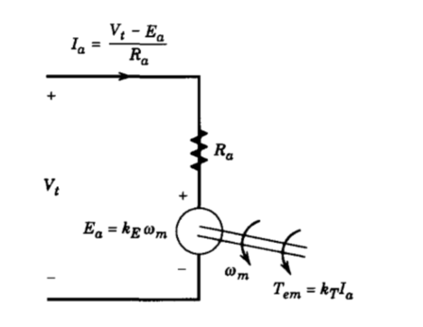

$T_{em}$ = $k_{T}*I_{a}$ (1)

$E_{a}$ = $k_{E}$ $w_{m}$* (2)

Figure 1: Equivalent circuit of DC motor

Because starting speed of the dc motor is very low produced torque and armature current is very high. However when speed increase this torque end current decrease. When we look at result of the Simulink model we can prove this theoretical information (Figure 2).

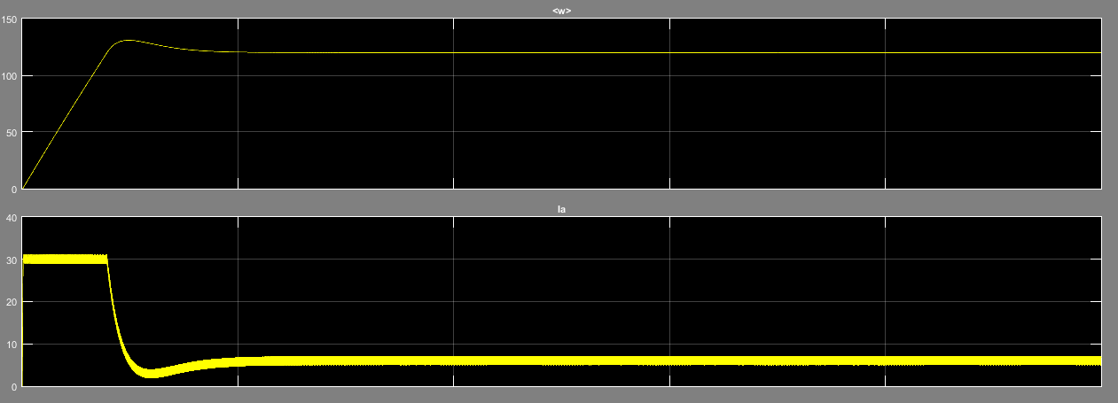

Figure 2: Speed and Armature current of DC motor versus time

Electrical power is calculated by multiplying motor voltage and armature current. This electrical power should be equal the mechanical power which is proportional to speed of dc motor and produced electrical torque under steady state condition. However by doing this equation losses should be neglected to exact result.

$P_{E}=E_{A}*I_{A}$ (Electrical Power) (3)

$P_{M}=w_{m}*T_{e}$ (Mechanical Power) (4)

In steady state;

$P_{E}=P_{M}$ (5)

Also speed of the motor is changes according to net torque which is the difference between the electrical and mechanical torque.

$T_{net }=T_{elec}-T_{mech}$ = J $\frac{dw}{dt}$ (6)

**Short Info about Power Source and Control System**

Schematic diagram of the Chopper-Fed DC Motor Drive system is shown as figure 3. Main parts of this system are speed controller, current controller and gate turn of thyristor (GTO). Speed controller compare the actual speed of dc motor and reference speed so it determine the error. For example reference speed is larger than actual speed so this means that speed acceleration is needed. In other words, more torque is required so more current which are shown above equation 1 and 6.

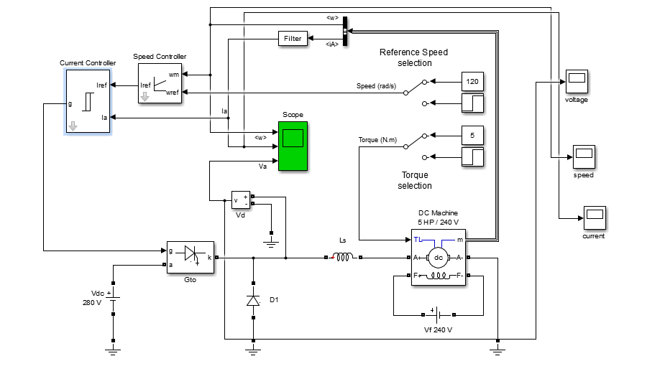

Figure 3: Schematic diagram of the Chopper-Fed DC Motor Drive

After that current is compared with the actual armature current thanks to current controller. Hence according to error GTO is controlled and motor voltage is adjusted automatically regardless of the speed. At this figure if we look at the analog voltage closely we can see that it is PWM so that we can adjust it easily (figure 4).

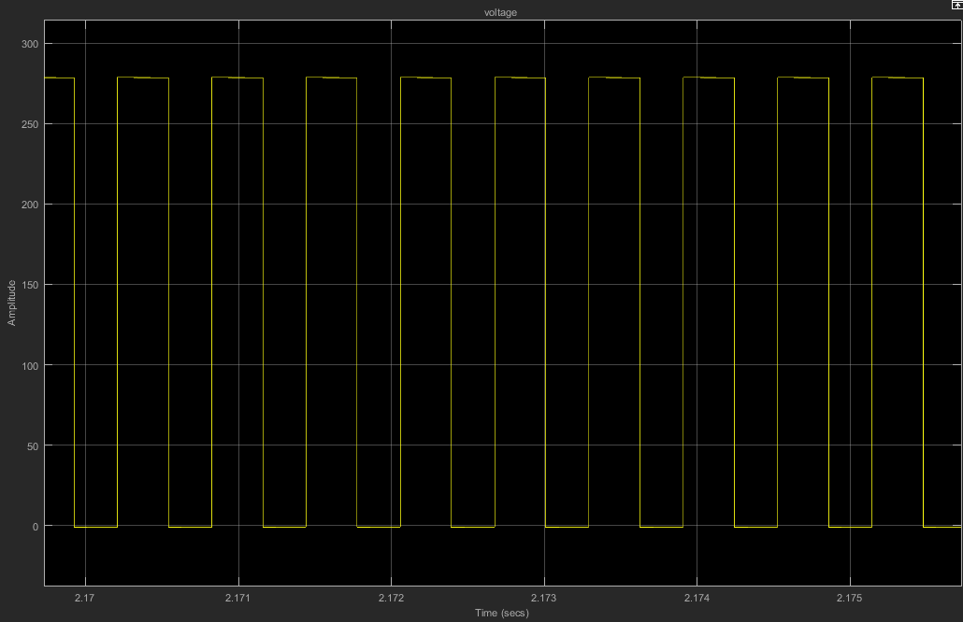

Figure 4: EMF voltage of dc motor

**Power calculation:**

At steady state mechanical power is $w_{m}*T_{e}$ according to equation 4. At steady state torque is 5 N*m and speed is the 120 rpm so we have approximately 600 Watt mechanical power.

When I examine result of the SIMULINK, using measurement tools of the time scope average current is 7.932 A, and average voltage is the 91.811 V. Produced electrical power is 728 Watt according to equation 3.

Difference between these two powers is power loss due to armature resistance or other characteristics of the dc motor.

**Startup Current Graph**

DC motor start with zero speed so the back EMF is the very low. Then armature current is the very high. Because it is directly proportional to difference of terminal and EMF voltage. Starting current graph is shown as figure 5.

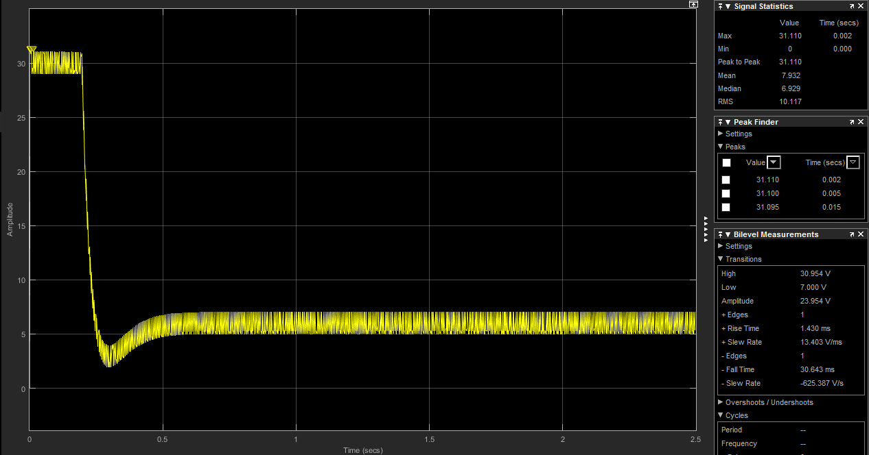

Figure 5: Starting Current Graph

**Produced Torque during Startup**

In this part I used equation 6. However equation 6 give me approximate result because many other effects is neglected here. In order to find acceleration of the speed again I used time scope of the SIMULINK figure 6.

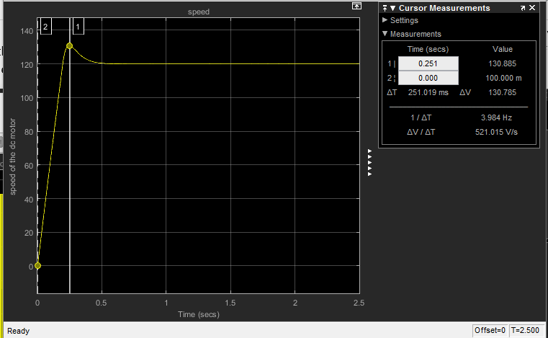

Figure 6: Acceleration of Speed of the DC Motor

According to figure 6;

$\frac{dw}{dt}$ = 521.015 rad/ $s^{2}$

$T_{net }=T_{elec}-T_{mech}$ = J $\frac{dw}{dt}$

So starting torque is = 0.05*521.015= 26.05 N*m

**References**

Mohan , Ned . Power Electronics. 2nd ed. N.p.: n.p., 1995. Print

Hughes , A. (n.d.). DC Motor Drive Basics- Part 3 Control Arrangements for DC Drive. Retrieved March 6, 2017, from http://www.eetimes.com/document.asp?doc_id=1274118